 |  | A/HRC/44/22
 | Advance Edited Version |  | Distr.: General  4 June 2020  Original: English
Human Rights Council
Forty-fourth session
Agenda item 2
Annual report of the United Nations High Commissioner
for Human Rights and reports of the Office of the
High Commissioner and the Secretary-General
Report of the United Nations High Commissioner for Human Rights on the situation of human rights in the Philippines
Summary
The present report is submitted pursuant to Human Rights Council resolution 41/2, which requested the High Commissioner for Human Rights to prepare a comprehensive written report on the situation of human rights in the Philippines and to present it at its forty-fourth session.

I. Introduction

1. In its resolution 41/2, the Human Rights Council requested the High Commissioner for Human Rights to prepare a comprehensive written report on the situation of human rights in the Philippines and to present it at its forty-fourth session.
2. This report presents an overview of the current human rights situation in the Philippines, guided by concerns highlighted in the preamble of Council resolution 41/2. It considers critical, ongoing issues, particularly where there are indications of long-standing, systematic causes underpinning them. In establishing trends and patterns, the report examines data since 2015 where possible, while also taking into account relevant developments prior to that.
3. The report is based on information collected and analysed by the Office of the United Nations High Commissioner for Human Rights (OHCHR), including through a public call for submissions. By 31 January 2020, OHCHR had received 893 written submissions, including joint submissions. These included 793 individually signed template-based letters. The Government of the Philippines provided substantial written input, including in response to two extensive lists of questions. OHCHR has also analysed official data and documents from governmental and non-governmental sources, including legislation, policy guidelines, court documents, police reports, videos, photos and open source reports, all used to corroborate information, along with interviews with victims and witnesses, remotely and in person. All sources were guaranteed confidentiality and are not named unless they provided specific consent.
4. OHCHR has had several exchanges with representatives of the Government of the Philippines, including detailed discussions on 13 and 14 February 2020 in Bangkok, Thailand. OHCHR is grateful to the Government for its openness to dialogue. OHCHR did not receive permission from the Government to conduct a visit to the Philippines.
II. Context
5. Following over three centuries of colonial rule, the Philippines achieved independence in 1946. The subsequent rule of President Ferdinand Marcos and imposition of martial law in 1972 were marked by serious human rights violations. Two internal armed conflicts emerged in the late 1960s – one in the Muslim-majority areas of the south, and another involving the New People’s Army (NPA) of the Communist Party of the Philippines (CPP) in various parts of the country.
6. In 1986, the “People Power” revolution toppled the Marcos administration and martial law was lifted. The 1987 Constitution included a Bill of Rights that emphasized social justice and human rights, and established an independent Commission on Human Rights. Other institutions, including commissions on women and youth and human rights offices within the Armed Forces of the Philippines (AFP) and the Philippines National Police (PNP), as well as the Presidential Human Rights Committee were also established at various points. In 2012, Administrative Order 35 established an Inter-Agency Committee on extralegal killings, enforced disappearances, torture and other grave violations involving political, environmental, agrarian and labour activists and media practitioners. Its effectiveness remains limited due to its perceived lack of independence, transparency and powers. It also does not cover drug-related killings. A Presidential Taskforce on Media Security was established in 2016 to investigate and prevent violent attacks against journalists. The Philippines has ratified the Optional Protocol to the Convention against Torture, and is taking steps to establish its National Preventive Mechanism.
7. The 1997 Indigenous Peoples’ Rights Act enshrined legal safeguards for indigenous peoples’ rights, addressing long-standing issues related to self-governance and land ownership. Effective implementation of this progressive legislation, however, remains elusive. Landed elites and political dynasties remain entrenched and wield extensive political and economic influence at national and local levels.
8. The 2014 Comprehensive Agreement on the Bangsamoro and the 2018 Bangsamoro Organic Law established the Bangsamoro Autonomous Region of Muslim Mindanao, ending the armed conflict with the Moro Islamic Liberation Front (MILF). A transitional government is now in place, with elections expected in 2022. Armed clashes between the Government and NPA persist, however, despite talks and several ceasefires over the past 50 years. In December 2017, the President proclaimed the CPP and its military wing, the NPA, as “terrorist entities”.
9. In recent years, other laws were passed to advance human rights, including on universal access to tertiary education and health care, mental health, sexual harassment, and children in situations of armed conflict. Magna Cartas of Women, the Poor and Persons with Disabilities have been enacted.
10. The Philippines is highly susceptible to natural disasters and the impacts of climate change, which exacerbate challenges in protecting human rights, notably economic, social and cultural rights.
11. The Philippines has ratified eight core international human rights instruments and has undergone three cycles of the Universal Periodic Review (2008, 2012 and 2017). The Government continued to actively engage with some Special Procedures mandate-holders, although the last official visit occurred in 2015, and the President has publicly insulted and even threatened some mandate-holders. The Philippines has engaged in technical cooperation activities with OHCHR, including with a Senior Human Rights Adviser supporting the United Nations country team since 2014.
III. Key human rights issues
12. The human rights situation in the Philippines is marked by an overarching focus on public order and national security, including countering terrorism and illegal drugs. This focus has permeated the implementation of existing laws and policies and the adoption of new measures, often at the expense of human rights, due process rights, the rule of law and accountability. Thus, while there have been important human rights gains in recent years, particularly in economic and social rights, the underpinning focus on national security threats – real and inflated – has led to serious human rights violations, reinforced by harmful rhetoric from high-level officials. While this report is unable to address the whole array of human rights issues highlighted in the submissions received – issues that would merit further examination – it focuses on key patterns of violations.
A. Human rights violations in the context of the campaign against illegal drugs
13. A 2015 survey found that approximately 1.8 million people in the Philippines (2.3 per cent of the population) were drug users. The challenges posed by illegal drugs have wide ranging human rights impacts and the Government has adopted an Anti-Illegal Drugs Strategy. But successive administrations have mostly employed increasingly violent law enforcement measures and disturbing rhetoric in the campaign against illegal drugs and related crimes, even as senior Government and police officials have questioned the impact and effectiveness of these policies.
14. This trend sharpened during the presidential election campaign of 2016, when current President Rodrigo Duterte pledged to kill criminals and eliminate corruption and drugs in “three to six months”. During his mayoral term in Davao City, hundreds of extrajudicial killings were documented which, according to the Special Rapporteur on extrajudicial, summary or arbitrary executions, “bore officially-sanctioned character”.
Alleged widespread and systematic killings
15. On 1 July 2016, President Duterte’s first day in office, he assigned Ronald dela Rosa, former Davao police chief, as Chief of the National Police. Dela Rosa immediately issued PNP Command Memorandum Circular No. 16-2016, launching the anti-illegal drugs campaign, project Double Barrel. One of its components is project Tokhang, designed to eradicate illegal drugs in the smallest local governance units, the barangays, through “house to house visitations to persuade suspects to stop illegal drug activities.”
16. House visitations raise important due process concerns as they did not require search or arrest warrants and could be conducted solely on the basis of a person’s inclusion on a “drug watch list”. Barangay officials compiled lists of suspected “drug personalities” and passed them to police. Individuals had no legal recourse to challenge their inclusion in the list. Police data reveals that of 42,286 police anti-illegal drugs operations conducted from 1 July 2016 until 30 November 2017, 507 – only 1.2 per cent – were based on an arrest warrant. In addition to the barangay lists, the President published “narcolists” of Government officials allegedly involved in the drug trade.
17. House visitations systematically forced suspects to make self-incriminating statements or risk facing lethal force. Circular 2016-16 encouraged “voluntary surrender”, but only mentioned access to counsel in case the person agreed to incriminate himself or herself, leaving individuals vulnerable to pressure and intimidation. Refusal of house visitation - even without a search or arrest warrant - was to result in “immediate case-build up and negation.”
18. The terms “negation” and “neutralization” of “drug personalities” appear throughout Circular 16-2016. Such ill-defined and ominous language, coupled with repeated verbal encouragement by the highest level of State officials to use lethal force, may have emboldened police to treat the circular as permission to kill. International human rights law prohibits arbitrary deprivation of life. While conducting law enforcement operations and using force, State officials must abide by key principles, including exercising restraint, using proportionate force strictly where necessary, and only deploying lethal force as a last resort in extreme cases.
19. The Government denies that there is a policy to kill people who use drugs and states that all deaths occur during legitimate police operations. According to the Philippine Drug Enforcement Agency, since the launch of Double Barrel on 1 July 2016 and until 31 January 2020, the police killed 5,601 persons. OHCHR could not independently verify this number. Various Government agencies have publicized conflicting figures and have proven reluctant to disclose documents related to the killings to the Supreme Court and the Commission on Human Rights.
20. There are also reports of widespread drug-related killings perpetrated by unidentified “vigilantes”. The Administration’s 2017 Year-End Report mentions 16,355 “homicide cases under investigations” as accomplishments in the fight against illegal drugs. This prompted the Supreme Court to raise the possibility that the killings were State-sponsored. Noting that drug operations by police and homicides perpetrated by unidentified persons resulted in 20,322 deaths from 1 July 2016 to 27 November 2017, the Supreme Court demanded an explanation for the staggering average of nearly 40 deaths per day. In March 2019, police claimed that although there were 29,000 deaths labelled as “deaths under inquiry” between 1 July 2016 and 4 February 2019, only 3,062 (9.47 per cent) were drug-related. A previous study, however, had found that police severely underreported the percentage of drug-related killings among homicides.
21. Between 1 June 2016 and 21 April 2020, the Commission on Human Rights documented the killing of 73 children in the context of the campaign against illegal drugs – 62 male and 11 female - although these figures are not exhaustive. The youngest victim was five months old.
22. OHCHR ultimately cannot verify the number of extrajudicial killings without further investigation. On the basis of information reviewed, the drug campaign-related killings appear to have a widespread and systematic character. The most conservative figure, based on Government data, suggests that since July 2016, 8,663 people have been killed – with other estimates of up to triple that number. This clearly illustrates the need for a transparent and comprehensive reporting system for data on killings by State and non-State actors.
23. Police reports disclosed before the Supreme Court offer insight into the conduct of 22 anti-drug operations in which 29 persons were killed – all in their homes. Except for one case, police conducted the operations without warrants. Pre-operational plans drawn up by police called for “immediate apprehension” and “neutralization” of targeted persons. Post-operational spot reports claimed that the targets were killed after resisting. The spot reports, however, contained strikingly similar language to describe each victim’s alleged utterance (“putang ina mo pulis ka pala” – which roughly translates as “so you are a police [officer], son-of-a-bitch”) and actions (“suspect drew his weapon, fired at the lawmen but missed”), raising doubts about whether the reports were only filled pro forma. The reports explicitly referred to the killing of five individuals as “neutralization”. Of the 29 persons killed, 23 were on the drug watch list.
24. OHCHR examined police reports on another 25 operations in which 45 persons were killed in Metro Manila between August 2016 and June 2017. Police referred to 34 of these killings as “neutralization”. In all the crime scenes, police claimed to have recovered satchels of methamphetamine and guns allegedly used by the victims to resist police officers. On the basis of these reports, OHCHR found that the police repeatedly recovered guns bearing the same serial numbers from different victims in different locations. OHCHR identified seven handguns with unique serial numbers. Each handgun appeared in at least two separate crime scenes, while two of them re-appeared in five different crime scenes. The pattern suggests planting of evidence by police officers and casts doubt on the self-defence narrative, implying that the victims were likely unarmed at the time of killing.
25. Although experienced nationwide, the impact of the campaign against illegal drugs has been better documented in urban areas. Limited data is available on the profile of those killed. According to one study, most victims were men from urban communities living in poverty. Submissions received by OHCHR confirm this pattern. Studies by the Commission on Human Rights and others also illustrate psychological and practical difficulties faced by family members – mostly women and children – when losing the male breadwinner.
Obligation to investigate
26. Despite credible allegations of widespread and systematic extrajudicial killings in the context of the campaign against illegal drugs, there has been near impunity for such violations. The Government states that the Police Internal Affairs Service (“IAS”) automatically investigates any deaths that occur during police operations. IAS reportedly launched 4,583 investigations between July 2016 and May 2019. Yet the Government has cited only one case – that of 17-year-old Kian delos Santos – where three police officers were convicted of a drug campaign-related killing. This outcome owes much to the availability of CCTV footage and public outrage following the murder. Although the Government noted that 9,172 police personnel faced administrative cases, it remains unclear how many of these cases are related to extrajudicial killings. OHCHR also notes that administrative sanctions are insufficient where there are serious allegations of violations of the right to life. OHCHR also notes the lack of progress in the investigation of anti-illegal drug campaign-related cases referred to the Office of the Ombudsman.
27. Police have invoked a “presumption of regularity” of operational conduct to justify the lack of prosecutions. The Supreme Court, however, has observed that “[police] cannot claim the presumption of regularity in official functions because deaths are not supposed to occur during any of [the police] operations”. The Government also asserts that law enforcement is unable to investigate killings in the absence of private complaints.
28. Under international human rights law, the Philippines is obliged to establish rules and procedures for mandatory reporting, review, and investigation of lethal and other life-threatening incidents by law enforcement personnel. Where there are allegations that it knows or should have known of potentially unlawful deprivations of life, it has the duty to investigate and, where appropriate, prosecute the perpetrators.
29. Relatives – mostly female – of victims, as well as lawyers and journalists interviewed by OHCHR, cited numerous obstacles in documenting cases and pursuing justice. These include surveillance, harassment, threats, intimidation, lack of education, lack of protection of witnesses and victims, a feeling of powerlessness in the face of official statements encouraging killings, unwillingness by law enforcement to investigate, and reluctance by judges to critically examine drug-related cases. Families interviewed by the Commission on Human Rights also expressed fears over the safety of their relatives, stigma, limited financial resources, and pressing basic needs of their household members – especially children – as reasons not to pursue legal action. Public assurances by the President to protect police officers even if they killed 1,000 persons while on duty have deterred victims from pursuing justice, and law enforcement agencies from investigating killings.
30. Submissions received by OHCHR also suggest widespread impunity for drug-related killings committed by unidentified persons and describe disturbing familiarity of masked perpetrators with locations and victims, suggesting possible collusion with police and local government officials in some cases.
Deprivation of liberty
31. International law prohibits arbitrary arrest and detention. Arrest or detention is arbitrary if it is unlawful or where there are sufficient elements of inappropriateness, injustice, lack of predictability and insufficient due process. Arbitrariness must also be assessed in light of necessity, proportionality and reasonableness.
32. Government figures indicate that 223,780 “drug personalities” were arrested from 1 July 2016 to 31 December 2019. The Government stated that 204,721 of these individuals were charged with criminal cases, although it is unclear how many may have been related to drug trade and how many to personal drug use, how many were convicted, released or remain in pre-trial detention. The lack of clarity, coupled with due process irregularities, raises concerns that many of these cases may amount to arbitrary detentions.
33. The high number of arrested persons strains the judiciary and prisons. With low court disposition rates, and delays in administration of justice, detainees have been languishing in often protracted pre-trial detention. In 2016, the United Nations Committee against Torture highlighted that pre-trial detainees accounted for 85-90 per cent of the detained population, mostly due to the strict application of the 2002 Comprehensive Dangerous Drugs Act. The Government is implementing measures to enhance efficiency in administration of justice, including through projects with international partners.
34. In February 2020, the prison congestion rate stood at 534 per cent and remains among the highest in the world. The congestion has been worsened by the increase in drug-related cases, a lack of judicial capacity to process criminal cases in a timely fashion, and poverty precluding many detainees from posting bail. A 2018 Government audit assessed that this violated standards of the Bureau of Jail Management and Penology and the UN Minimum Standard Rules for the Treatment of Prisoners, and the Government is building or upgrading jail facilities. OHCHR welcomes various measures to decongest detention facilities, including a recent Supreme Court initiative that led to the release of nearly 10,000 prisoners during the COVID-19 outbreak.
The right to health
35. All persons who use drugs retain the right to health. Treatment of drug dependence is an element of the right to health, which should be ensured in compliance with human rights principles of non-discrimination, respect for the inherent dignity of an individual, confidentiality, privacy, and informed consent.
36. In 2018, the Philippines adopted an anti-illegal drugs strategy encompassing provisions for treatment and rehabilitation. In cooperation with the World Health Organization, the Government is establishing pilot recovery clinics for persons who use drugs. The 2002 Comprehensive Dangerous Drugs Act, however, imposes six months of mandatory drug rehabilitation for first-time drug users, violating the principle of voluntary treatment. Compulsory drug treatment is inconsistent with international drug control conventions and human rights law.
37. According to the Government, 497,775 people who use drugs have undertaken a PNP recovery and wellness programme from 1 January 2018 to 31 December 2019. A further 524,320 such persons have undergone a community-based rehabilitation programme. Only 26,200 individuals have undergone treatment and rehabilitation in centres managed and accredited by the Department of Health. OHCHR is concerned that the involvement of law enforcement agencies in drug rehabilitation programmes runs counter to the provision of evidence-based medical treatment and rehabilitation services.
38. The 2002 Comprehensive Dangerous Drugs Act also requires mandatory drug testing and reporting of drug users in public facilities - including secondary schools. This may breach the right to privacy, generate stigmatization, and constitute degrading treatment. The law also prescribes severe sanctions that can be manifestly disproportionate to the particular offence, such as lengthy prison sentences for mere possession of small amounts of illegal drugs. Criminalization of personal use, coupled with disproportionate sentencing, hinders people from obtaining appropriate treatment for drug use.
39. OHCHR also notes with concern the lack of harm reduction programmes supported by the Government, such as opioid replacement or provision of syringes. These programmes are also absent from detention facilities.
B. National security and civic space
40. Alongside the intensified campaign against illegal drugs, the State has scaled up its response to countering terrorism and conflicts, which also impact on human rights. OHCHR has examined key national security laws and policy, and their acute impact on civil society, including human rights organizations, lawyers, political and judicial actors, journalists and trade unionists, church groups and others, particularly through the phenomenon of “red-tagging”.
Overarching national security and counter-terrorism legislative framework
41. While the Constitution and laws contain strong human rights provisions, several laws give the authorities wide discretion to detain and charge individuals on the grounds of national security without adequate human rights safeguards. These include the Human Security Act of 2007, the 2012 Cyber Crime Protection Act, the 2018 Republic Act 10973 (known as the subpoena powers law) and laws on sedition.
42. Worrying new laws and amendments have been proposed with the stated aim of strengthening public order and countering terrorism, which risk eroding constitutional and other legal protections. Proposed bills to restore the death penalty for drug-related offences, and to significantly lower the age of criminal responsibility would breach the Philippines’ obligations under international human rights law. The proposed 2020 Anti-Terrorism Act, slated to replace the already problematic Human Security Act, dilutes human rights safeguards, broadens the definition of terrorism and expands the period of detention without warrant from three to 14 days, extendable by another 10 days. The vague definitions in the Anti-Terrorism Act may violate the principle of legality.
43. A spate of emergency measures has also been imposed in recent years. A nationwide state of emergency proclaimed on 4 September 2016 – two days after a bombing in Davao City in which 14 civilians were killed – remains in force more than three years later. State of emergency measures must be limited to the extent strictly required by the exigencies of the situation, in duration and geographic scope. In the Philippines, what should have been an exceptional state appears to have become normalized.
44. Additionally, in May 2017, martial law was declared across Mindanao when Marawi City was under siege by a coalition of ISIL-affiliated armed groups. Martial law was extended by the Congress three times, until the last extension expired in December 2019.
45. In November 2018, Memorandum Order 32 authorized the immediate deployment of additional AFP and PNP officers “to suppress lawless violence and acts of terror in the provinces of Samar, Negros Oriental, Negros Occidental, and the Bicol region”. While there was violence in these areas prior to the implementation of the Order, information obtained by OHCHR and statements by the Commission on Human Rights indicate that the subsequent joint police-military operation may have resulted in serious human rights violations, including alleged killings and arbitrary detention. There are also alarming reports of violations of international humanitarian law, including in the conduct of aerial bombing operations. These require further investigation.
46. On 4 December 2018, President Duterte signed Executive Order 70 “to institutionalize the whole-of-nation approach to end the insurgency by the end of his term in 2022, by strengthening the counter-insurgency program with a comprehensive socio-economic development component.” It created a National Task Force to End Local Communist Armed Conflict (NTF-ELCAC). The stated aim is “inclusive and sustainable peace and economic vitality in hundreds of communities still vulnerable to, or under the grip of the NPA’s influence.” The Government reports resources equivalent to USD 438 million have been allocated for social and economic development programs under Executive Order 70.
47. The departure from a predominantly militarized response to preventing and countering violent extremism is encouraging, but this can only be sustainably achieved through meaningful participation of affected communities, respect for human rights and the rule of law. There are concerns, however, that implementation of Executive Order 70 appears to be going in the opposite direction, mobilizing the administration, from national to local levels, against suspected communist sympathizers and sowing further suspicions and divisions in communities. Advocacy for economic and social rights comes with the risk of being labelled anti-Government and thus pro-insurgency, which may hinder the goal of inclusive and sustainable development. There are concerns that these patterns resemble those that characterize the anti-illegal drugs campaign, notably a presumption of guilt and lack of due process or effective oversight – this time against those suspected of supporting the CPP-NPA.
48. Against this backdrop, there has been a more than fivefold increase over five years in the national budget for opaque “intelligence and confidential” activities – 8.28 billion Philippine pesos (USD 163 million) in 2020 compared with 1.49 billion (USD 29 million) in the 2015 budget. Of this allocation of 8.28 billion pesos, over half (4.5 billion pesos) is allocated to the Office of the President.
Impact on civic space
49. The Philippines has a long-standing, robust tradition of human rights advocacy and civil society activism, with 60,000 registered non-governmental organizations. This is particularly striking given the pervasive attacks – online and offline – against human rights defenders over many years. For decades now, “red-tagging” – or labelling individuals and groups as communists or terrorists – has been a persistent and powerful threat to civil society and freedom of expression.
50. Since 2007, various United Nations human rights mechanisms have repeatedly raised concerns about vilification, threats, arbitrary detention, legal harassment, enforced disappearances and killings of human rights defenders. OHCHR requested but did not receive Government figures on killings of human rights defenders, but credible civil society sources have compiled detailed lists documenting hundreds of killings. OHCHR has itself verified the killings of 208 human rights defenders, journalists and trade unionists, including 30 women, between January 2015 and December 2019. Despite efforts to strengthen the dedicated mechanism under Administrative Order 35, the Government has failed to ensure transparent, independent and effective investigations and prosecutions in the vast majority of cases. Of 383 cases dating back to 2001 under the mechanism, 216 have been either dismissed or archived while only 13 have resulted in convictions.
51. The pervasive nature of Government red-tagging is clearly illustrated by the inclusion of 649 names in a Government court petition to designate CPP and NPA as terrorist groups under the Human Security Act. The list included indigenous and other rights defenders, and a United Nations Special Rapporteur. Many individuals were subsequently removed from the list, but continued to report harassment, and were labelled as terrorists. On 5 November 2019, a senior AFP intelligence official provided Congress with a list of national and international organizations that allegedly provide financial support to and serve as fronts for the “communist terrorist group”. in spite of independent audits providing evidence to the contrary for several of the organizations.
52. Such public labelling has proven extremely dangerous. In 2018, for instance, posters and hit lists claiming to depict photos of CPP-NPA-NDF personalities were circulated in Negros Island. At least four of the human rights defenders listed were subsequently murdered: activist Haide Flores, lawyer Benjamin Ramos Jr, city councilor Bernardino Patigas, and lawyer Anthony Trinidad. All four murders remain unsolved.
53. Numerous human rights defenders have shared with OHCHR death threats they received in text messages, phone calls or on social media. One red-tagged rights defender, Honey Mae Suazo, has been missing since 2 November 2019. She had previously received many threats in relation to her work documenting violations against peasants and indigenous peoples in southern Mindanao. Other women human rights defenders have additionally been threatened with rape and harassed with sexual slurs.
54. Police and military visits and raids on NGOs are reportedly used to intimidate civil society, including during the COVID-19 lockdown. Some individuals are detained and released, while others face charges including for illegal possession of firearms, abduction and sedition. While judicial remedies such as the Supreme Court’s writ of amparo are available, in one recent case, civil society members seeking temporary protection orders against the Government were themselves charged with perjury.
55. Red-tagging, harassment and killings of trade unionists continues. Intervention by State security forces in union meetings and affairs, threats and profiling of members – including of a national alliance of teachers – have been reported. The International Labour Organization Committee on Freedom of Association has also raised concerns about “blanket linkages of trade unions to an insurgency” placing unionists in situations of extreme insecurity.
56. Lawyers’ groups worldwide have been raising the alarm on killings of legal professionals in the Philippines since 2004, but the numbers documented have risen considerably over the past five years. OHCHR has corroborated information that, since 2015, over 40 legal professionals have been killed, many who were working on politically sensitive cases or advocating for land rights of farmers and indigenous peoples. Others have faced attempts on their lives. Most cases remain unresolved. Reprisals, threats and criminal charges, often for non-bailable offences, against legal professionals involved in human rights cases are also prevalent. Many lawyers and judges decline or recuse themselves from such cases.
57. In 2018, the Supreme Court removed from office Chief Justice Maria Lourdes Sereno - a prominent critic of the “war on drugs” and the extension of martial law in Mindanao - following a Government petition in relation to her non-declaration of assets prior to her appointment in 2012. The Commission on Human Rights denounced her removal, recalling that under the Constitution, a Chief Justice can only be removed through impeachment by Congress. UN Special Rapporteurs warned that her dismissal has a “chilling effect” on judicial independence.
58. Senators Leila de Lima and Risa Hontiveros are among other women officials critical of Government policy who faced reprisals. Senator de Lima has been arbitrarily detained for three years and Senator Hontiveros faces various criminal charges. Furthermore, Vice-President Leni Robredo and former Senator Antonio Trillanes were among individuals accused of conspiracy to commit sedition, although charges against the Vice-President have been withdrawn. On 20 April 2020, seven people linked to the Anakpawis political party were charged with sedition for reportedly carrying printed material critical of the Government while handing out food packets to quarantined communities in Bulacan, Luzon, during the COVID-19 outbreak.
59. Some welcome steps have been taken to address impunity for killings of journalists. In December 2019, 43 people were convicted in relation to the 2009 killing of 32 media workers in Ampatuan, Maguindanao province. Several legal cases against journalists and prominent media organizations are, however, pending. For instance, the Securities and Exchanges Commission in 2018 revoked the license of a prominent news website Rappler. While Rappler continues operations, its CEO, Maria Ressa, has been arrested multiple times on various charges. OHCHR and various United Nations Special Rapporteurs raised concerns about what appears to be “a pattern of intimidation” of independent news sources. In February 2020, the Office of the Solicitor-General filed a petition to revoke the franchise of major broadcaster ABS/CBN after the President threatened to shut it down, claiming that its reporting was biased against him. On 5 May, the National Telecommunications Commission issued a “cease and desist” order against ABS/CBN when its legislative franchise expired, leading to immediate shutdown of its broadcasting services and raising serious concern about freedom of the press. Congressional hearings on renewal of the network’s license were ongoing at the time of writing.
60. The Philippines has one of the highest per capita uses of social media globally, with Facebook the dominant platform. While it is an important tool for civil society to share information and analysis, it has also been used to spread misinformation, troll, red-tag and harass civil society and opposition politicians, with women particularly subjected to misogynistic comments. Facebook has removed at least 200 pages, groups and accounts engaging in coordinated inauthentic behavior on Facebook and Instagram, which it found were linked to a network organized by the President’s electoral campaign social media manager. The Government has also increasingly filed criminal charges, including by using COVID-19 special powers laws, against social media users posting content critical of Government policies and actions.
61. Twenty media and NGO websites also faced a spate of distributed denial of service attacks in 2018 and 2019 after posting stories critical of officials. A lawsuit relating to the attacks was settled out of court in March 2020.
C. The situation of indigenous peoples, farmers and internally displaced people
62. As of 31 March 2020, 359,941 individuals remained displaced in Mindanao due to armed conflicts and natural disasters – many protractedly displaced, including 127,865 following the 2017 siege of Marawi.
63. There are serious concerns that the persistent lack of security and economic development in Mindanao, including insufficient progress in rebuilding Marawi, reported violations of international humanitarian law, and the lack of progress in transitional justice and reconciliation provide fertile ground for radicalization. Whereas no hostilities have been reported between MILF and AFP since the establishment of BARMM in 2018, armed clashes are ongoing in other parts of Mindanao with ISIL-affiliated non-State armed actors: the Abu Sayyaf Group, the Bangsamoro Islamic Freedom Fighters and the Maute group.
64. Ongoing clashes between AFP and NPA, as well as the activities of other armed groups, continue to cause internal displacements in eastern and northern Mindanao. The implementation of martial law in Mindanao and Memorandum Order 32 in Negros has increased militarization in the region, with far-reaching impact on the rights of the farmers and indigenous peoples, in particular.
Land, farmers and indigenous peoples
65. The Philippines’ legal framework for the rights of indigenous peoples remains, on its face, exemplary. Powerful business and political actors, however, consistently undermine efforts at land distribution and agrarian reform. The requirement for free and prior informed consent for any interventions in indigenous communities is regularly manipulated, including through bribery and intimidation, as noted in multiple independent studies. While the National Commission on Indigenous Peoples has substantial powers, there remains mistrust in its effectiveness and independence.
66. The indigenous Lumad peoples have for decades been caught in a tug of war between AFP and NPA. Accusations based on perceived affiliation with one side or other are common, and often precede arbitrary detention, as well as threats, violence and killings by both State and non-State actors. Further issues arise from the role of private mining and logging companies, infrastructure projects and large-scale agribusiness on ancestral lands, and in implementation of the land distribution programme for peasants.
67. Various controversial large-scale projects to which the indigenous communities have not consented remain pending, including, for example, the Kaliwa Dam project in Quezon. State officials have publicly expressed exasperation with the process and threatened to push projects through. In other cases, companies continue to operate without appropriate consent from the communities, such as in Luzon, where a 2011 Commission on Human Rights inquiry found that the mining company OceanaGold was responsible for the illegal demolition of 200 houses and violent eviction of residents.
68. The establishment of Citizen Armed Force Geographical Units (CAFGUs) in 1987, “force-multipliers” in 2006 and other armed groups led to an increase in extrajudicial killings and other violence against those perceived to be anti-Government, pro-NPA or anti-business. In 2012, the United Nations Human Rights Committee urged the State to disband and disarm all “private armies, vigilante groups and ‘force multipliers’”. Such armed groups have, however, continued to proliferate, and act with apparent impunity.
69. Land and environmental rights defenders feature prominently among the documented killings of human rights defenders, particularly in Mindanao, Negros, the Cordillera Administrative Region, Palawan and Bataan province. Information provided by civil society and the Commission on Human Rights suggests widespread impunity for such killings.
70. In one emblematic case, a Commission on Human Rights investigation found that the killing by the military of tribal leader, Datu Victor Danyan – one of eight Lumad killed in Lake Sebu in South Cotabato in December 2017 – amounted to a human rights violation. To date, there has been no accountability. Danyan had refused to consent to renewing authorization for a coffee plantation. AFP, for its part, stated that the killing occurred during an encounter with NPA. Similarly, veteran peasant leader Nora Apique, working on agrarian reform and land claims, was shot and killed on 31 March 2020 by unidentified assailants on her way home in San Miquel, Surigao del Sur province.
71. As many indigenous communities are geographically isolated, without adequate access to basic social services, they rely heavily on civil society support. The emphasis on national security, intelligence-gathering, and red-tagging in the execution of Executive Order 70, however, has hampered local civil society, including church groups, from tending to the humanitarian needs of the communities for fear of being portrayed as NPA affiliates.
72. Teachers and students of NGO-run indigenous community learning centres have also long been attacked and harassed. On 25 February 2019, several banners were posted outside a school in North Cotabato province, accusing it of links with NPA. On 12 July 2019, the Government closed 54 such schools in Mindanao, stating they were acting on complaints that the schools were teaching violent extremism. UNICEF has expressed concerns about the closures.
73. The 2019 report of the United Nations Secretary-General on children and armed conflict cited verified attacks and threats of attacks on schools and teachers, mainly for perceived support for NPA. The majority of these violations were attributed to AFP, which also used two schools as bases during military operations.
Violations and abuses by the New People’s Army
74. OHCHR received individual submissions alleging human rights abuses by NPA, including killings, abductions, recruitment of children and extortion.
75. Without access to the country, OHCHR was unable to verify these reports. The Commission on Human Rights has, however, verified reports of killings by NPA, and the Government has stated that 80 incidents allegedly perpetrated by the NPA are being examined under Administrative Order 35. United Nations reports confirm grave violations against children committed by both State and non-State actors, including the killing of 16 children (including four killed by AFP and one by the Abu Sayyaf Group), and maiming of 41 (including four by AFP, three by NPA and one by the Maute Group) in 2018.
76. The United Nations has verified the recruitment and use of 12 children by NPA in combat or support roles in 2019, and one by AFP to provide support in a military camp. The United Nations lists the NPA among parties that commit grave violations affecting children in situations of armed conflict.
D. Incitement to hatred and violence
77. In recent years, harmful rhetoric from the highest levels of the Government has been pervasive and deeply damaging. Some statements have risen to the level of incitement to violence.
78. The rhetoric has ranged from degrading and sexually-charged comments against women human rights defenders, politicians and combatants – including rape “jokes” – to statements making light of torture, calling for bombing of indigenous peoples, encouraging extreme violence against drug users and peddlers – even offering bounties, calling for beheadings of civil society actors, and warning that journalists were not immune from “assassination”. Days after the imposition of COVID-19-related restrictions on movement, the President declared in an address to the nation that police, military and barangay officials were to shoot those disobeying orders, creating trouble or fighting. In response to criticism about distribution of relief supplies, he also threatened to detain “the left” until the COVID-19 crisis was over. The Commission on Human Rights commented that the President’s “statement is dangerous as it may be construed as an official policy from the Government.” The PNP Chief subsequently stated that the police would “exercise maximum tolerance” and act “within the bounds of the law.”
79. Other high-level officials have also used incendiary language inciting violence against Government critics. On 5 March 2020, reacting to a media comment by an NGO, a Minister tweeted that “These are f---ing Communists. You shoot them. You don’t listen to them.” The tweet was later removed, and the Minister’s Twitter account temporarily blocked.
80. While numerous statements by President Duterte are subsequently clarified by his spokesperson and other officials as not to be taken literally, the widespread killings, detentions, red-tagging and score-settling by State actors, including in the campaign against illegal drugs, suggest that his public comments may have incited violence and may have had the effect of encouraging, backing or even ordering human rights violations with impunity. The use of such language could amount to a violation of the prohibition against arbitrary deprivation of life in Article 6 of the International Covenant on Civil and Political Rights.
IV. Conclusion
81. The legal, constitutional and institutional framework in the Philippines contains human rights safeguards, as well as checks and balances. The challenge has always been one of implementation – and circumvention. The long-standing overemphasis on public order and national security at the expense of human rights has become more acute in recent years, and there are concerns that the vilification of dissent is being increasingly institutionalized and normalized in ways that will be very difficult to reverse.
82. In just the first four months of 2020, including during the COVID-19 pandemic, OHCHR documented killings of drug suspects and human rights defenders. Charges were filed against political opponents and NGO workers, including for sedition and perjury. A major media network was forced to stop broadcasting after being singled out by the authorities. Red-tagging and incitement to violence have been rife, online and offline. The response to COVID-19 has seen the same heavy-handed security approach that appears to have been mainstreamed through the ramped-up drug war and counter-insurgency imperatives. While important measures were taken to mitigate the pandemic’s economic impact on vulnerable communities, threats of martial law, the use of force by security forces in enforcing quarantines, and the use of laws to stifle criticism have also marked the Government’s response.
83. Persistent impunity for human rights violations is stark and the practical obstacles to accessing justice within the country are almost insurmountable. Human rights advocacy is routinely equated with insurgency and the focus diverted to discrediting the messengers rather than examining the substance of the message. This has muddied the space for debate, disagreement and for challenging State institutions and policies, resulting in deep mistrust between Government and civil society – a rift that urgently needs to be repaired.
84. The country faces major systemic challenges, from structural poverty, inequalities, armed conflict, natural disasters and now the nationwide impact of COVID-19. OHCHR welcomes important efforts to improve the protection of economic and social rights and access to essential goods and services across the country. It is crucial, however, that this be guided by a human rights-based approach, focused on “leaving no one behind”. Efforts to address criminality, the trade and use of illicit drugs and to prevent and counter violent extremism and armed conflict must be grounded in evidence, consistent with the rule of law and with full respect for the human rights of all affected persons. Accountability for violations committed by both State and non-State actors, with full transparency and respect for due process, are essential for rebuilding public confidence.
85. Given the widespread and systematic nature of the alleged killings, and the failure of domestic mechanisms to ensure accountability thus far, there have been strong calls for an international accountability mechanism. In June 2019, a group of 11 Special Procedures mandate-holders called on the Human Rights Council to establish an independent investigation. The International Criminal Court, for its part, is conducting a preliminary examination of the situation in the Philippines. The High Commissioner again emphasizes the need for independent, impartial and effective investigations into the killings and stands ready to assist credible efforts towards accountability at the national and international level.
86. The High Commissioner expresses OHCHR’s readiness to continue positive engagement with the Philippines, including through enhanced provision of technical assistance and capacity building, particularly in the implementation of the recommendations of this report, and continued monitoring and reporting on progress on human rights.
V. Recommendations
87. The High Commissioner calls on the Government of the Philippines to:
a. In context of its campaign against illegal drugs:
i. Repeal PNP Command Memorandum Circular No. 2016-16, cease ‘Project Tokhang’ and urgently put an end to extrajudicial killings, arbitrary detention and other violence targeting suspected drug offenders and people using drugs; Abolish the compilation and publication of ‘drug watch lists’ at all administrative levels;
ii. Undertake a comprehensive review of legislation and policies relating to narcotics, including revisiting the mandatory penalties for drug offences; Consider decriminalization of personal possession and use of certain drugs; Implement alternative measures to conviction and punishment and other human rights-based responses;
iii. Ensure adequate assistance to families of victims of drug-related killings, including financial aid, legal support and psycho-social services.
b. National security laws and policies:
i. Rescind Memorandum Order 32; Ensure emergency measures are necessary, proportionate and time-bound, limited to those strictly required by the exigencies of the situation;
ii. Urgently disband and disarm all private and State-backed paramilitary groups;
iii. Review Executive Order 70 and its implementation to ensure compliance with the rule of law and international human rights norms and standards, and that political and socio-economic grievances are tackled through meaningful, participatory consultation;
c. Accountability:
i. Empower an independent body to conduct prompt, impartial, thorough, transparent investigations into all killings, and into alleged violations of international humanitarian law, with a view to prosecution and remedies for victims and their families;
ii. Improve systems to compile and publish consistent, disaggregated data on all allegations of extrajudicial killings;
iii. Improve cooperation between law enforcement bodies and the Commission on Human Rights; strengthen its investigative and forensic capacity, including through adoption of the Commission on Human Rights Charter; Adopt legislation establishing a National Preventive Mechanism on Torture;
d. Civic space:
i. Take confidence-building measures to foster trust with civil society organizations and facilitate their engagement with State institutions mandated to respond to human rights concerns, without reprisal; Halt - and condemn – incitement to hatred and violence and other harmful, threatening and misogynistic rhetoric against human rights defenders and other Government critics – offline and online;
ii. Ensure that the rights to freedom of expression, association and peaceful assembly are respected and protected; Drop politically-motivated charges against human rights defenders, political opponents, journalists and media organizations, legal and judicial officials, trade unionists, church workers, and others; Take legal measures to ensure their protection, particularly following threats, including of gender-based violence; Ensure there are no reprisals against those persons and entities which have engaged with OHCHR for the present report;
e. Indigenous peoples:
i. Fully and comprehensively implement the Indigenous People’s Rights Act and address, together with affected communities, the major challenges impeding its proper functioning;
ii. Ensure full respect for the principle of free, prior and informed consent and meaningful participation at all stages of development projects that affect indigenous communities;
iii. Ensure universal access of indigenous children to quality education in line with their cultural identity, language and values.
f. Cooperation with OHCHR and UN human rights mechanisms:
i. Invite Special Procedures mandate-holders to monitor and report on specific human rights concerns in the Philippines and provide relevant technical assistance;
ii. Invite OHCHR to strengthen its provision of technical assistance, inter alia, to advise on reviewing counter-terrorism legislation, adopting human rights-based approaches to drug control, strengthening domestic investigative and accountability measures, improving data gathering on alleged police violations, and to assist in bridging the gap between civil society and State authorities.
88. The High Commissioner calls on the international community, including the Human Rights Council to:
i. Encourage and support technical cooperation between the Government and OHCHR to implement the recommendations of this report, with the participation of the Commission on Human Rights and civil society:
ii. Mandate OHCHR to continue monitoring and documenting the situation of human rights in the Philippines, and to regularly report to the Human Rights Council, including on progress in technical cooperation;
iii. In the absence of clear and measurable outcomes from domestic mechanisms, consider options for international accountability measures;
iv. Remain engaged with regard to possible reprisals against human rights defenders;
v. Bolster implementation of the Guiding Principles on Business and Human Rights and conduct strict human rights due diligence in carrying out investment and development cooperation, particularly in relation to infrastructure projects, extractive industries and cooperation involving the security sector.

Annexes
Annex I:
Illustrative cases – victims’ voices
The following three cases of alleged extrajudicial killings illustrate some of the key issues highlighted in the report. The stories were compiled through interviews with victims and witnesses, family members, as well as a review of official documentation and videos to corroborate information. In all the cases, there is a need for thorough, impartial and transparent investigations.
Benjamin Ramos – human rights lawyer
After more than 30 years of defending the rights of farmers in Negros, multiple threats, frequent red-tagging and surveillance, attorney Benjamin Ramos was shot dead on 6 November 2018. Two hooded assassins on a motorbike fired three bullets into the victim in Kabankalan city centre on Negros Island. CCTV footage captured the motorcycle speeding away. The Presidential spokesperson condemned the killing, pledging to bring to justice the perpetrators. To date, however, there has been no justice for his family, and Ramos’ colleagues continue to face threats and vilification.
Benjamin Ramos was one of the most active lawyers and human rights defenders on Negros island. He started his work as a community organizer in the 1980s and was a founding member of the National Union of People’s Lawyers (NUPL) and the secretary-general of its Negros Occidental chapter. Witnessing the difficulties that the Negros sugar plantation farmers faced, he was determined to work towards improving their socio-economic situation, his wife Clarissa Ramos told OHCHR. He worked on various issues related to the State’s agrarian reform programme, land ownership, mining and the situation of sugar workers, among others.
“Through his community work, Ben quickly realized that if the farmers did not possess the land – the whole effort is futile. He became interested in the agrarian reform and decided to pursue legal studies in order to deepen his understanding of the law. He felt that this knowledge would help the farmers to assert their rights,” explained Clarissa Ramos, herself a human rights defender.
Benjamin Ramos’ legal advocacy and pro bono work with the Negros communities quickly earned him powerful enemies, including landowners, mining corporations, and military officers. Over the decades, Ramos frequently faced surveillance and was increasingly publicly accused by the military of being affiliated with the NPA. His name was aired on a radio programme, telling listeners not to seek legal advice from him as he was a front for the NPA. His picture appeared on a poster along with other rights defenders tagged as CPP-NPA-NDF personalities, and he was similarly maligned in PowerPoint presentations conducted by the military. Over the years, Ramos also lost several of his NUPL colleagues to assassinations, and he himself on occasion was followed by motorcycle-riding men, his wife said. In October 2018, after nine sugar workers were killed in Sagay City, Negros Occidental, Ramos took up the case. Two weeks later, Ramos himself was killed.
Despite the availability of CCTV footage and numerous witnesses to the circumstances of Ramos’ assassination, there remains widespread fear to assist police with the investigation, Clarissa Ramos said.
“If they can kill a lawyer – imagine what they can do to a lay person?” one witness said in an interview with OHCHR. Following his death, Ramos’ family and colleagues were subjected to further acts of surveillance, threats, and intimidation, including credible reports suggesting the involvement of military intelligence. Two of his colleagues were sent photos of coffins, warning they would be next.
Ramos is survived by his three children and his wife. “I will continue to pursue justice for my husband through all available venues, both in the Philippines and internationally,” Clarissa Ramos said.
Elisa Badayos and Eleuterio Moises – human rights defenders
From 26 to 28 November 2017, Elisa Badayos, a long-time human rights defender and an NGO coordinator for Central Visayas, led a team of 30 individuals on a fact-finding mission to Negros Island. The purpose of the mission was to investigate and document human rights violations allegedly committed by private security guards, the Citizen Armed Force Geographical Units (CAFGUs), and the Armed Forces of the Philippines (AFP). The team also included Eleuterio Moises, member of the local peasant organization, Mantapi Ebwan Farmers’ Association. On the last day of their mission, 28 November, at around 2:40 p.m., Badayos and Moises were shot dead by motorcycle-riding gunmen.
Members of the fact-finding team recalled in interviews with OHCHR how on 28 November, in Bayawan city, their vehicle was stopped by a group of armed guards. Some of the guards were reportedly members of the CAFGU. The men reportedly worked for an influential local family with close ties to the municipal government. The guards brandished their weapons and asked the team about the purpose of the mission. The team showed the guards the municipal permit they had obtained to conduct their work. The armed men relented and allowed the team to proceed.
The fact-finding team separated into smaller groups and conducted interviews with victims and witnesses. Badayos and her team spoke to farmers who told them that security guards employed by a powerful local politician were attempting to drive farmers off the land. After the interviews with farmers, Badayos, Moises and other colleagues got on two motorbike to go to the Nangkay barangay hall in Bayawan to file a police report on the harassment they had faced from the armed men. The team that witnessed the killing recalls noticing they were being followed by masked armed men on another motorbike.
The witnesses say that Badayos, Moises and another colleague were shot – and the gunmen took pictures of their victims before driving off. Badayos and Moises were pronounced dead on arrival at the hospital, while the third colleague survived.
Elisa Badayos’ daughter Jimmylisa was part of the mission: “I recall my mission colleague receiving a call informing us that something happened to my mother. My heart sank.”
The Philippine National Police opened an investigation into the incident but despite witness testimonies and CCTV footage capturing the suspects on a motorbike, the case remains unsolved. A Commission on Human Rights investigation concluded that while human rights violations have been committed in the attack, failure to collect evidence has precluded the case from moving forward.
Colleagues of the murdered human rights defenders and labour activists shared with OHCHR the continued threats they have been receiving on social media in relation to their work in Bohol, Cebu and Negros, and told also of intimidating visits from individuals who introduce themselves as representatives of the Government.
Elisa Badayos is survived by her four children, including Jimmylisa. Elisa’s husband Jimmy Badayos, a labour organizer, disappeared in 1990 after being arrested and taken away by police in Cebu city. His fate and whereabouts remain unknown.
The Lozano brothers – on a drug watch list
According to the Philippine National Police, brothers Crisanto (34) and Juan Carlos Lozano (31) were killed on 12 May 2017 after a robbery incident in Arboretum, Quezon City. The police report claimed that three men allegedly took a mobile phone of a victim at gunpoint and then fled in a passenger “jeepney” vehicle. Police allegedly caught up with the trio a few kilometers down the highway, and after a shootout, killed all three suspects. Officers said they recovered two guns – .38 caliber and .45 caliber – beside the bodies of Crisanto and Juan Carlos. Both victims were on the barangay’s “drug watch list”.
According to victims’ relatives interviewed by OHCHR, the day before the killing, the two brothers had gone out early to see their uncle and to get clearances and referrals for work. After failing to hear from the brothers throughout the day, the family grew worried. They printed out the brothers’ pictures and started approaching police stations throughout Quezon City. Eventually the family got a call that bodies believed to be of the two brothers were brought into police camp Karingal in Quezon City. There, they were able to identify the bodies as Crisanto and Juan Carlos.
Crisanto and Juan Carlos’ mother, Llore Benedicto, said the police told the family that a police-accredited funeral parlour took the bodies from the morgue. The parlour, notorious for profiteering off the anti-illegal drugs campaign, reportedly had close ties with local police, claimed unidentified bodies and processed them for a fee. Benedicto said that the parlour asked for PHP 112,000 (approximately USD 2,200), to be paid on the day before the internment. The family did not have the money, so the parlour refused to let her even see her sons’ bodies. It took days for the family to negotiate the price down to PHP 75,000 – of which PHP 50,000 was to be paid in cash for the release of the bodies and the remaining PHP 25,000 had to be settled before the family could get death certificates required for the burial.
Eight days after her sons were killed, Llore Benedicto finally saw their bodies. “I asked myself, is this what it feels to lose someone in the President’s ‘war on drugs’? I lost my loved ones and I still get to suffer in every step – including the funeral home.”
The victims’ family denied that Crisanto and Juan Carlos ever owned guns, and said that while they had used drugs in the past, they had stopped doing so for more than a year prior to their killing.
The family did not pursue a case against the police due to the lack of means, witnesses, a lack of faith in the justice system, and for fear of retaliation, Benedicto said.
“Everybody knows that unless you have evidence or witnesses willing to step forward, the case will not go anywhere,” admitted Llore Benedicto. She vowed, however, to continue her quest for justice in international venues: “When a grieving parent or family cries because of a violent experience like this…I learned that when you cry, you gain more strength to fight. To fight for justice no matter how long.”

The following is an account of the killing of a municipal councilor, allegedly by NPA, for refusal to pay “revolutionary taxes”. The account is drawn from submissions received by OHCHR and an investigation by the Commission on Human Rights. The real names, dates and locations are not used in the account below, for the protection of surviving family members
At around 7am on 15 May 2019, more than 50 heavily armed people on board three trucks stopped outside the house of municipal councilor Jose dela Suarez, according to his mother. She said the armed men scattered themselves and broke into the room where dela Suarez was, with his wife and young child. The three of them hid under their bed, but dela Suarez was spotted by one of the armed men, who immediately sprayed him with bullets, pulled him out and stabbed him repeatedly, according to the victim’s sister.
The men then gathered money and jewellery from the house before driving off, chanting “mabuhay ang NPA” (“long live the NPA”), the victim’s mother said.
An investigation by the Commission on Human Rights interviewed witnesses who said that dela Suarez had been repeatedly approached by individuals claiming to be NPA, demanding “revolutionary taxes”. Dela Suarez refused to pay over many years. A year prior to his killing, dela Suarez had received a letter warning him against running for re-election.

Suspects have been identified in the case and court proceedings are ongoing.

OHCHR received a number of accounts of NPA violations. Further investigations are required in such cases. While there are no comprehensive figures on NPA violations, the Government has informed OHCHR that 80 incidents allegedly perpetrated by NPA are being monitored under Administrative Order 35.

Annex II:
Posters, social media posts and print-outs targetting human rights defenders
These images threatening human rights defenders are open source and circulating in the public domain. Some were discussed in the Philippines Senate. Images blurred by OHCHR.
Image 1:
Left - a poster that claims to be bearing pictures of suspected CPP-NPA-NDF (“CNN” personalities) in Moises Padilla town, in Negros Occidental. The phone number listed is a local police number. Circled in the poster, Bernardino Patigas (6th row) and Anthony Trinidad (second row from the bottom), have been killed.
Right - a “hitlist leaflet” declaring 15 people, including activitst Haide Flores (spelled Heidi below) and lawyer Anthony Trinidad, as NPA that “will be judged”. It was distributed by Kagubak, an anti-communist group in Guihulngan City, also in Negros Occidental.
The circled human rights defenders have since been killed. Several others have received threats and some have faced attempts on their lives.
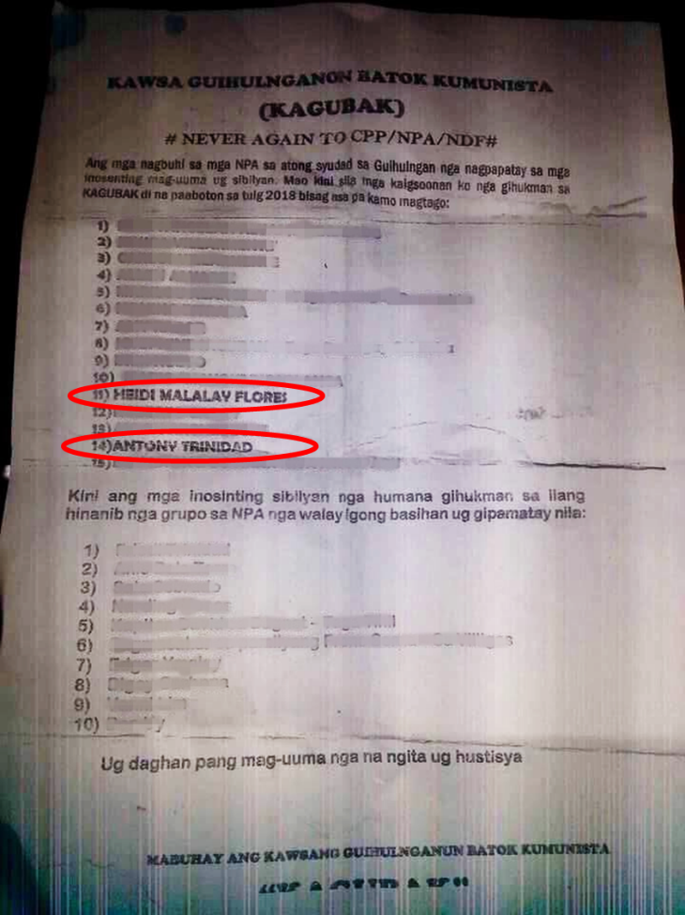
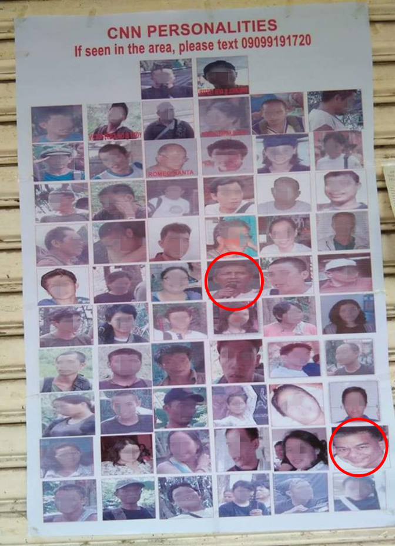

Image 2:
Redtagging of an activist (circled in image) on Facebook, and the threat she subsequently received via a direct message. Faces blurred by OHCHR.
Left - Facebook post with the caption: “UP Cebu Kabataan Partylist, one of the many NPA partylists. So they can get money from the Government. REMEMBER THEIR FACES!”
Right - Private Facebook message to an activist which reads: “Fourteen bullets for 14 communists…..Stop it, or else we will make you stop.”
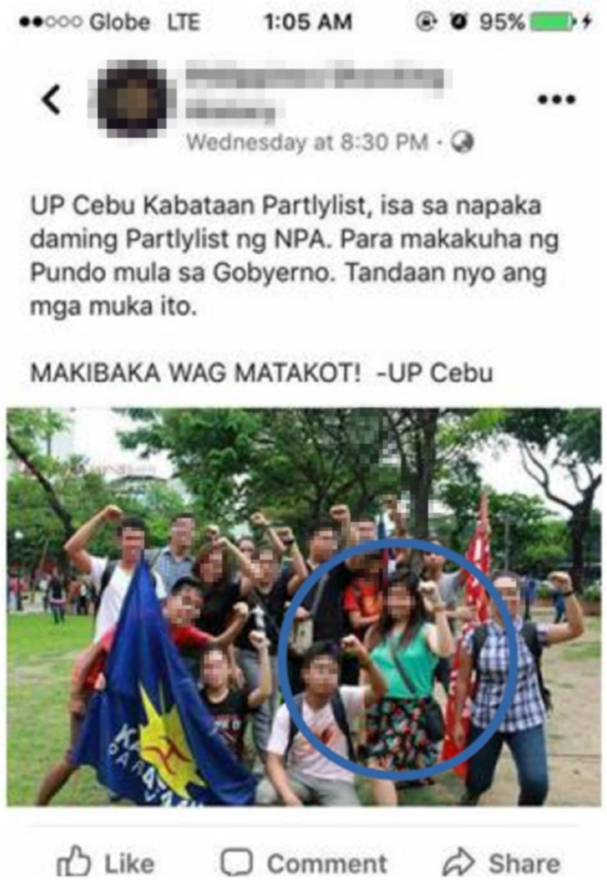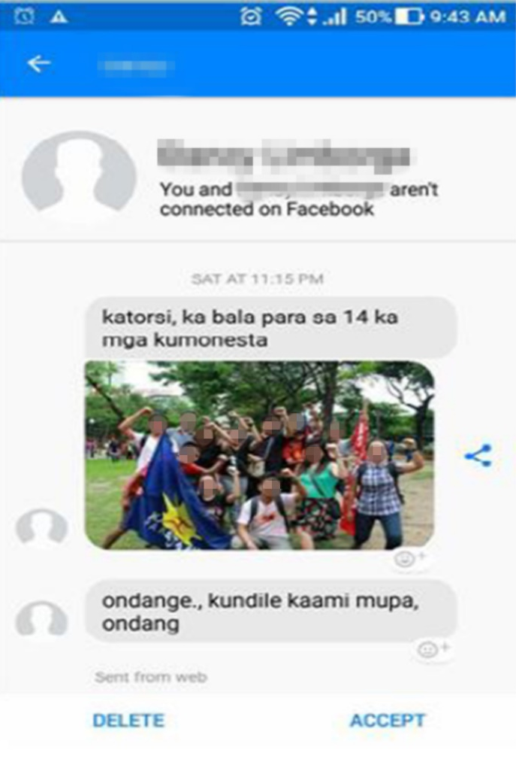

Image 3:
An image widely circulated on social media, depicting prominent NGOs as “the real virus”. The text reads: “The CPP-NPA-NDF viruses that should be avoided along with COVID-19. Together we fight terrorists! Overthrow CPP-NPA-NDF!”. This image appeared on the Facebook page of the AFPs 303rd Infantry Brigade on April 30, 2020. https://www.facebook.com/303rdbrigade.philarmy/posts/903439520101515
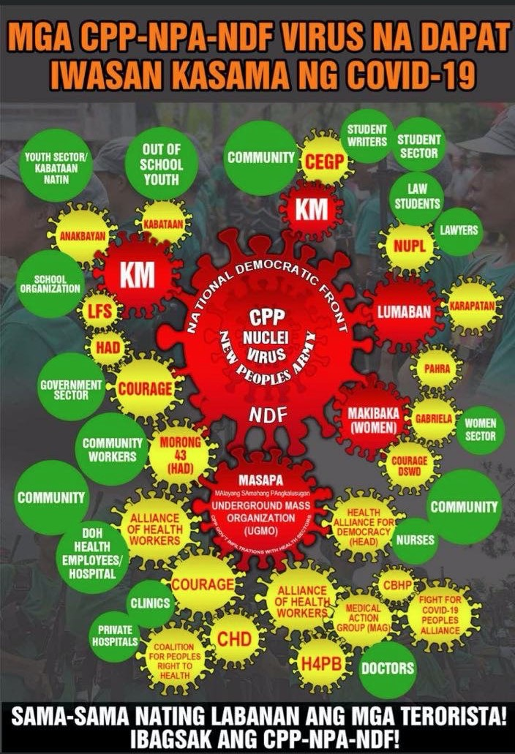
Images 4:
Death threats received on 24 November 2018 by two colleagues of slain human rights lawyer Benjamin Ramos Jr, some 18 days after his unsolved murder. The text reads “Now we are looking at you, you will be next.” Black bars added by OHCHR.
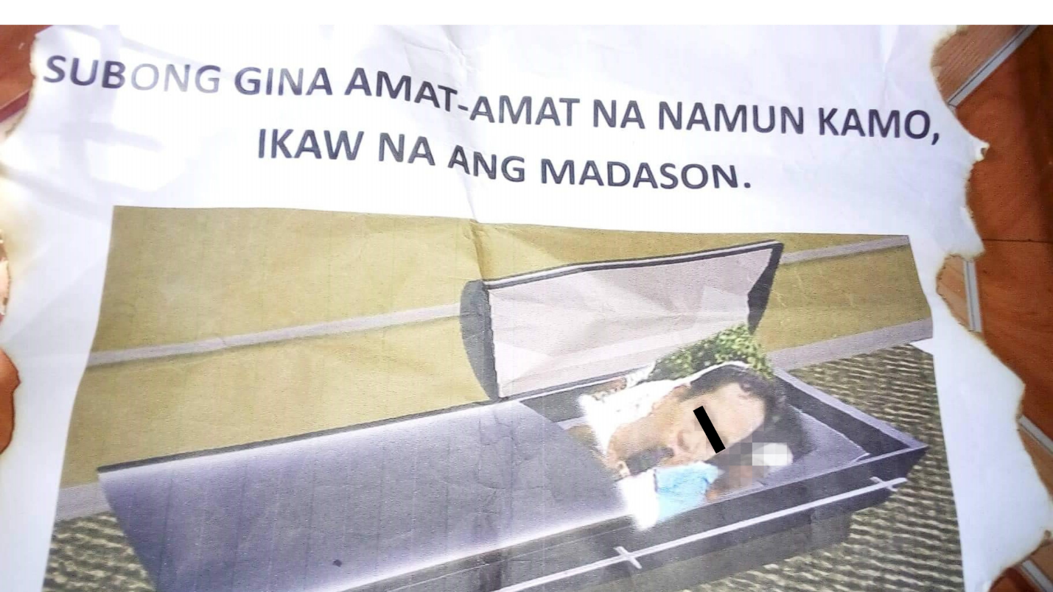
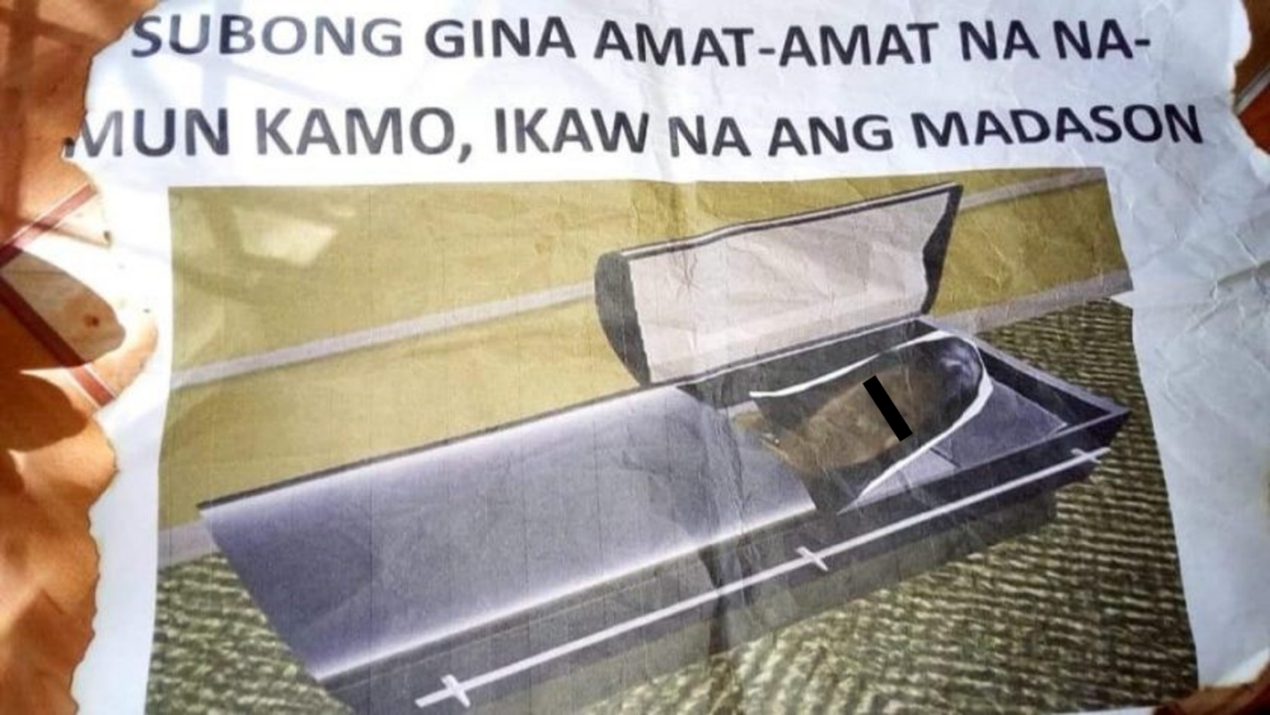

Annex III:
Map of the Philippines:

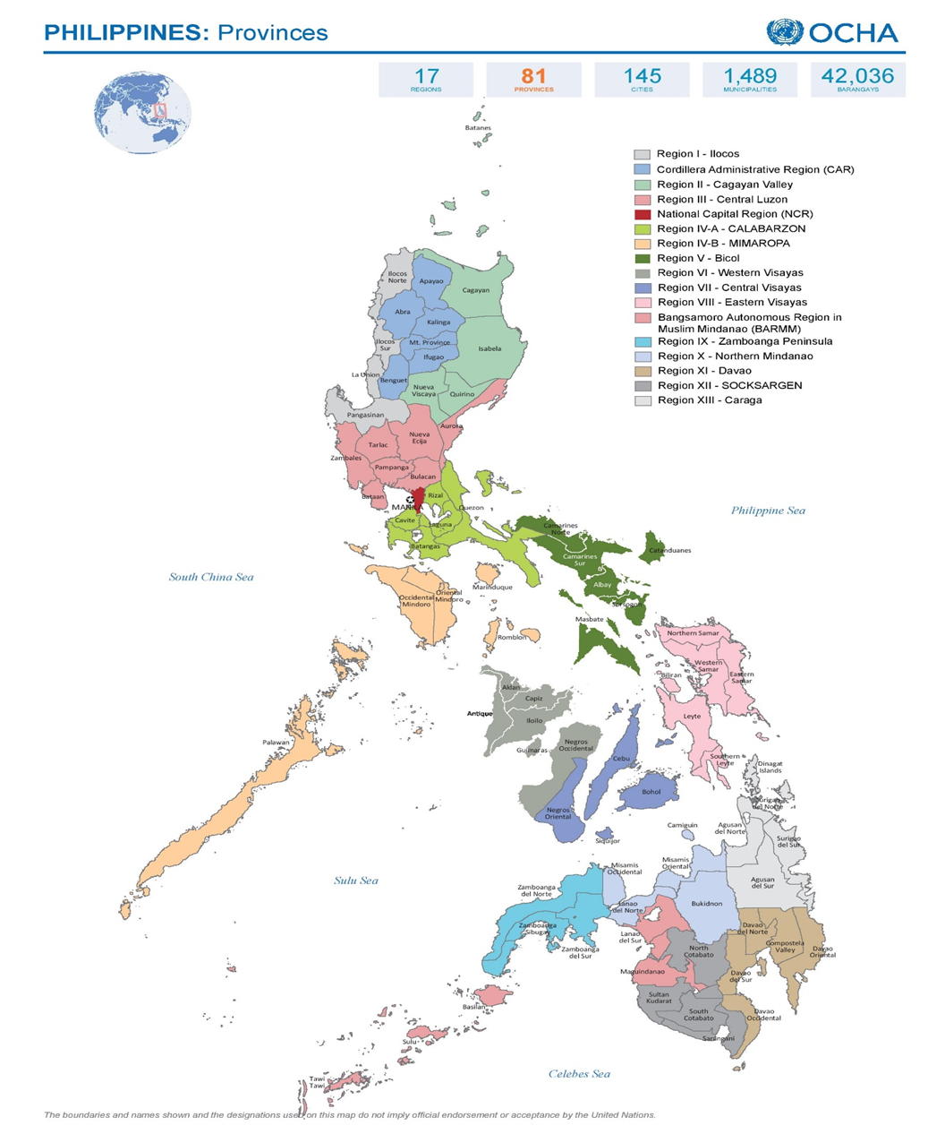

A/HRC/RES/41/2
See for example: https://www.ilo.org/wcmsp5/groups/public/---asia/---ro-bangkok/---ilo-manila/documents/publication/wcms_713337.pdf
Presidential Proclamation No. 374, 5 December 2017
Republic Acts No. 10931, No. 11223, No. 11036, No. 11313, No. 11188
It has not ratified the 2007 International Convention for the Protection of All Persons from Enforced Disappearance
A/HRC/32/35/Add.3
For example: https://www.ohchr.org/EN/NewsEvents/Pages/DisplayNews.aspx?NewsID=22421&LangID=E
2015 Nationwide Survey, Dangerous Drugs Board, p 54
For example, President Arroyo called drug use ‘Enemy No 1 of the entire Filipino People’, see 2001 Letter of Instruction No. 1. See also unsubstantiated claims in https://www.philstar.com/nation/2011/05/22/688117/80-heinous-crimes-drug-related-ddb-chief
Co-Chairperson’s Report, Inter-Agency Committee on Anti-Illegal Drugs, 6-24 November 2019, pp 35-40. See also https://www.reuters.com/article/us-philippines-drugs-performance-exclusi/exclusive-shock-and-awe-has-failed-in-philippines-drug-war-enforcement-chief-says-idUSKBN2010IL and https://pcoo.gov.ph/wp-content/uploads/2019/04/20190402-SPEECH-OF-PRESIDENT-RODRIGO-ROA-DUTERTE-DURING-HIS-ATTENDANCE-TO-THE-PARTIDO-DEMOKRATIKO-PILIPINO-LAKAS-NG-BAYAN-PDP-LABAN-CAMPAIGN-RALLY.pdf
https://news.abs-cbn.com/video/nation/05/25/15/duterte-criminals-tataba-yung-isda-sa-manila-bay-dyan-ko-kayo-itatapon
https://www.philstar.com/headlines/2016/02/20/1555349/duterte-vows-end-criminality-3-months
Civil society documented 553 extrajudicial killings in Davao between August 1998 and February 2007. See A/HRC/8/3/Add.2 (2008), fn 56
Ibid, para 39
https://didm.pnp.gov.ph/images/Command%20Memorandum%20Circulars/CMC%202016-16%20PNP%20ANTI-ILLEGAL%20DRUGS%20CAMPAIGN%20PLAN%20%20PROJECT%20DOUBLE%20BARREL.pdf
Board Regulation No. 2 (2007), Dangerous Drugs Board, Section 1(a). In 2008, Special Rapporteur Philip Alston recommended this function abolished. See A/HRC/8/3/Add.2 (2008), p 24, para 68(b)
Petitioners vs Dela Rosa et al., Notice of Resolution, Supreme Court, 3 April 2018, pp 32-33
Petitioners vs Dela Rosa et al., Supplemental Memorandum by the Petitioners, Supreme Court, 21 October 2019, pp 26-27
https://pcoo.gov.ph/news_releases/president-duterte-bares-names-of-narco-politicians/
For example https://www.philstar.com/headlines/2016/07/02/1598740/duterte-pnp-kill-1000-ill-protect-you
CCPR/C/GC/3 (2018), paras 4, 11
1990 UN Basic Principles on the Use of Force and Firearms by Law Enforcement Officials, art 2(a)-(b)
Petitioners vs Dela Rosa et al, Notice of Resolution, supra note 17, p 6, 9
#RealNumbersPH, Philippine Drug Enforcement Agency, 31 January 2020.
See the discrepancies documented in https://dahas.upd.edu.ph/database/
https://www.rappler.com/nation/181519-duterte-order-pnp-chr-refuse-share-case-folders; http://bbc.com/news/world-asia-49203752; also Petitioners vs Dela Rosa et al., Notice of Resolution, supra note 17, p 45
The Duterte Administration Year-End Report: 2017, p 22
Petitioners vs Dela Rosa et al., Notice of Resolution, supra note 17, p 48
Ibid
https://www.philstar.com/nation/2019/03/06/1898959/29000-deaths-probed-drug-war-launched
https://data.world/stabile-center/ph-drug-war
Submission of the Commission on Human Rights, 5 May 2020
Petitioners vs Dela Rosa et al., Supplemental Memorandum, supra note 18, p 3
The Killing State: The Unrelenting War Against Human Rights in the Philippines (2019), PhilRights, pp 7-17
Panaghoy: The War on Drugs from the Perspective of Women and Children, Commission on Human Rights of the Philippines, pp 27-38
Government submission, 1 May 2020
https://www.dilg.gov.ph/news/DILG-Internal-cleansing-in-PNP-on-going-despite-controversies-9172-erring-personnel-facing-admin-raps/NC-2019-1272
Meeting with Government representatives, 13-14 February 2020
Petitioners vs Dela Rosa et al., Notice of Resolution, supra note 17, p 47
Meeting with Government representatives, 13-14 February 2020
CCPR/C/GC/36 (2018), paras 13, 27-29. See also 2016 Minnesota Protocol on the Investigation of Potentially Unlawful Death
OHCHR interviews, 24, 26-27 February and 4 March 2020
Panaghoy, supra footnote 35, p 39
https://www.philstar.comt/headlines/2016/07/02/1598740/duterte-pnp-kill-1000-ill-protect-you
CCPR/C/GC/35 (2014), paras 10-12
Co-Chairperson’s Report, supra note 10, p 11
Judiciary Annual Reports 2017, 2018
CAT/C/PHL/CO/3, para 13
Government submission, 1 May 2020
2018 Annual audit report of the Department of the Interior and Local Governance, Commission on Audit, pp 54-56
Administrative Circular 38 (2020), Supreme Court
A/65/255 (2010), para 7
https://www.unodc.org/documents/drug-prevention-and-treatment/UNODC-WHO_International_Standards_Treatment_Drug_Use_Disorders_April_2020.pdf
https://www.ddb.gov.ph/images/downloads/Revised_PADS_as_of_Nov_9_2018.pdf
Department of Health Administrative Order 2019-0005
A/65/255, para 30
https://www.ohchr.org/EN/NewsEvents/Pages/DisplayNews.aspx?NewsID=24369&LangID=E
Section 11 of 2002 Dangerous Drugs Act, E/C.12/PHL/CO/5-6
Government submission, 1 May 2020
In 2012, the United Nations Human Rights Committee warned the Human Security Act carried offences that were too broad in scope. See CCPR/C/PHL/CO/4
See: https://www.ohchr.org/Documents/HRBodies/CCPR/NV_from_HRC_ThePhilippines_28March2017.pdf, also http://www.ohchr.org/Documents/Countries/PH/OpenLetterHC_DeathPenalty.pdf and https://www.unicef.org/philippines/press-releases/lowering-age-criminal-responsibility-against-child-rights-unicef
CCPR/C/GC/35 (2014), para 15
See A/36/40, annex VII, general comment 5/13 pp.110; and A/HRC/37/52, para 11
https://www.officialgazette.gov.ph/2017/05/23/proclamation-no-216-s-2017/
See for example https://chr.gov.ph/statement-of-chr-spokesperson-atty-jacqueline-de-guia-on-the-deployment-of-more-troops-in-bicol-region-samar-and-negros-provinces/ and infra footnote 78, and http://chr.gov.ph/statement-of-chr-spokesperson-atty-jacqueline-ann-c-de-guia-on-the-recent-spate-of-killings-in-negros-oriental/ and http://chr.gov.ph/statement-of-the-commission-on-human-rights-on-the-series-of-arrests-of-activists-in-negros-occidental-and-metro-manila/
See examples of airstrike: https://www.pna.gov.ph/articles/1084364
Government submissions, 31 January 2020
See also https://newsinfo.inquirer.net/1226413/chr-wants-eo-that-justifies-attacks-on-activists-revoked
https://www.dbm.gov.ph/wp-content/uploads/GAA/GAA2020/TechGAA2020/OP/OP.pdf and https://www.dbm.gov.ph/index.php/budget-documents/previous-years
See Dissenting opinion of Associate Justice Leonen in Carlos Isagani Zarate et al., Supreme Court, 10 November 2015, p 1
See https://gojust.org/
See for example: https://www.ilo.org/wcmsp5/groups/public/---asia/---ro-bangkok/---ilo-manila/documents/publication/wcms_713337.pdf
See A/HRC/39/41, A/HRC/42/30 and https://tbinternet.ohchr.org/Treaties/CERD/Shared%20Documents/PHL/INT_CERD_EWU_PHL_8679_E.pdf
http://www.congress.gov.ph/legisdocs/cdb/cdb18-v1i33-20191105.pdf. See also: https://philippines.oxfam.org/latest/press-release/oxfam-statement-inclusion-afp%E2%80%99s-list-%E2%80%9Ccommunist-terror-groups%E2%80%9D
For example, an independent audit process by the Government of Belgium found no irregularities with the Alliance for the Advancement of People’s Rights (Karapatan), see https://www.dekamer.be/doc/CCRI/pdf/55/ic075x.pdf
See annexes I and II
Special Procedures, Urgent Appeal PHL, 26 December 2019
See also infra fn 90
See Urgent Appeal PHL, supra note 77. Also see https://cnnphilippines.com/regional/2020/2/7/tacloban-raid-progressive-group.html
See also supra fn 6 and infra fn 85
https://www.pna.gov.ph/articles/1095366
https://www.ilo.org/wcmsp5/groups/public/---ed_norm/---relconf/documents/meetingdocument/wcms_713974.pdf
See https://www.deped.gov.ph/2019/01/07/statement-on-the-alleged-inventory-of-alliance-of-concerned-teachers-members-by-the-philippine-national-police/ and https://news.abs-cbn.com/news/01/06/19/alliance-of-concerned-teachers-slams-police-profiling
Case No. 2528, Report No. 356, March 2010
https://lawyersforlawyers.org/en/philippines-lawyers-organizations-worldwide-call-on-aquino-government-to-address-attacks-against-filipino-lawyers/
Numerous submissions from lawyers’ groups corroborate these reports.
https://pcoo.gov.ph/aug-09-2016-news-releases/
https://chr.gov.ph/statement-of-the-chr-on-the-sc-decision-to-oust-chief-justice-sereno/
https://www.ohchr.org/EN/NewsEvents/Pages/DisplayNews.aspx?NewsID=23163&LangID=E
https://www.ohchr.org/Documents/Issues/Detention/Opinions/Session82/A_HRC_WGAD_pdf; 2018; A/HRC/42/30; PHL 5/2017; A/HRC/40/60/Add.1; A/HRC/40/52
https://www.pna.gov.ph/articles/1100378
https://www.ohchr.org/en/NewsEvents/Pages/DisplayNews.aspx?NewsID=24171&LangID=E
https://www.ohchr.org/Documents/Issues/Detention/Opinions/Session82/A_HRC_WGAD_2018_61.
https://about.fb.com/news/2019/03/cib-from-the-philippines/ See also: http://www.tsek.ph
See for example PNP nabs 47 Covid-19 fake news peddlers: https://www.pna.gov.ph/articles/1099910 and this https://www.dole.gov.ph/news/press-statement-on-the-deportation-of-a-filipina-caregiver-in-taiwan-for-the-crime-of-cyber-libel/
See https://www.qurium.org/alerts/philippines/attributing-the-attacks-against-media-human-rigths-philippines/ and https://www.altermidya.net/parties-to-cyberattack-cases-reach-agreement/
UNHCR Mindanao Displacement Dashboard, March 2020, Issue No. 67
In particular, recommendations of the Transitional Justice and Reconciliation Commission: http://www.tjrc.ph/
See https://www.giz.de/en/downloads/giz2013-en-assessing-free-and-prior-informed-consent-fpic-phillipinen.pdf and A/HRC/32/35/Add.3.
https://reliefweb.int/report/world/global-terrorism-index-2019
See https://www.ohchr.org/EN/NewsEvents/Pages/DisplayNews.aspx?NewsID=22567&LangID=E
The President’s mid-term report to the people 2019
https://www.scribd.com/document/389045428/Commission-on-Human-Rights-Resolution-on-OceanaGold-in-the-Philippines. See also UN experts’ statement, 30 April 2020: https://www.ohchr.org/EN/NewsEvents/Pages/DisplayNews.aspx?NewsID=25850&LangID=E
1987 Executive Order 264; 2006 Executive Order 546
Supra footnote 61, para 14
https://www.pna.gov.ph/index.php/articles/1018556
A/73/907–S/2019/509
UN Secretary-General reports on children and armed conflict, 2015-2019
Supra fn 102
Fifth UN Secretary-General Country Report on the Philippines, Children and Armed Conflict, 2017-2019
Supra fn 107
https://pcoo.gov.ph/presidential-speech/nation-address-of-president-roa-duterte-on-coronavirus-disease-2019-covid-19-pandemic/ and https://news.mb.com.ph/2020/04/03/palace-defends-dutertes-shoot-to-kill-order-vs-troublemakers/
https://www.facebook.com/notes/commission-on-human-rights-of-the-philippines/statement-of-chr-spokesperson-on-the-order-to-shoot-alleged-agitators-and-violat/2713442025438992/
CPR/C/GC/36 (2018)
https://www.ohchr.org/EN/HRBodies/HRC/Pages/NewsDetail.aspx?NewsID=24679&LangID=E

